21-08-2025

Dev
- Build a dashboard for easy inputs and analysis
- Accessibility for everyone irrespective of the background
- Understandability : Tech and Non-tech also
- Add ML model for prediction

Disha
Deliverables
- Use case diagrams & process flows.
- Business case document.
- Data profiling (cleaning, identifying issues).
- Data model creation.
- Importing and preparing data in Oracle.
SQL Phase
- Build views for 3 scenarios:
  - Scenario 1: Customer demographics (age, gender, region, marital status, dependents, available assets).
  - Scenario 2: Customer risk tolerance (relationship between age, assets, and region).
  - Scenario 3: Revenue & risk analysis for funds (weighted average risk score, min/max revenue).
PL/SQL Phase
- Create functions and procedures for dynamic reporting.
- Functions must cover:
  - Assigning customers to risk tolerance categories (based on questionnaire).
  - Calculating revenue (min/max).
  - Weighted average risk score of funds
- Procedures for CRUD operations with data integrity checks.
- Add triggers & constraints:
  - Asset distribution ≤ 100%.
  - Proper address formatting.
  - Duplicate detection & remediation.

22-08-2025

Sabs

Financial Advisor -

Use Case 1 - View Segmented Customer Profile -> Dashboard to filter and see data

Use Case 2 - Recommend Suitable Fund -> Model to recommend fund to people

Use Case 3 - Simulate Fund Performance -> Calculator

Use Case 4 - Generate Fund Investment Report -> Auto Generate PDFs

Wealth Strategy Director

Use Case 1 - View Segment Analytics -> Dashboard to see charts and analysis

Use Case 2 - Adjust and approve fund structure -

Use Case 3 - Monitor fund KPIs - Dashboard

Senior Database Engineer

Use Case 1 - Build data architecture -> Access to Database tools, pipelines

Use Case 2 - Integrate customer data sources -> API Integration

Business Analyst

Use Case 1 - Document business requirements

Use Case 2 - Define segmentation criteria

Use Case 3 - Coordinate dashboard creation

Senior Project Manager

Customers

Use Case 1 - Register/Login

Use Case 2 - Risk Assesment Survey

Use Case 3 - View Portfolio

Use Case 4 - View Recommended Funds

Developer

Design Data Model & Architecture
Implement Data Integration
Develop Reporting & Dashboards
Deploy & Maintain System

System Administrator
Manage user accounts & permissions
Monitor database/server performance
Backup & recovery
Regulatory Authority / Compliance Officer
Ensure fund compliance with government/SEBI rules
Review audit & compliance reports

Investor Relations / Customer Support
Answer customer queries about funds
Provide onboarding & FAQs
Handle complaints
External Data Provider
Supply market data (stock indices, commodities, etc.)
Feed economic indicators for risk analysis
—------------------------------------------------------------------------------------------------------------------------

Stakeholder Analysis:
1. Customer
What do we require from them?
Registration and risk survey input.
Portfolio data and engagement preferences.
What do they require from us?
Portfolio view, recommended funds, risk assessment results.
Why do they require it?
To make informed investment choices and track portfolio.
Priority: High
Perspective: End-user; expects trust and simplicity.
Personality: Risk-conscious, outcome-focused.
2. Financial Advisor
What do we require from them?
Validate fund model recommendations.
Provide input on fund suitability.
What do they require from us?
Dashboards for customer profiles.
Fund recommendations.
Fund performance simulation tools.
PDF investment reports.
Why do they require it?
To give accurate and personalized investment advice.
Priority: High
Perspective: Customer-facing, advisory role.
Personality: Analytical, client-focused, detail-oriented.
3. Wealth Strategy Director
What do we require from them?
Approve and adjust fund structures.
Strategic direction for portfolio offerings.
What do they require from us?
Dashboards with segment analytics and KPIs.
Insights into fund performance trends.
Why do they require it?
To align fund strategies with organizational goals.
Priority: High
Perspective: Executive-level, strategic thinker.
Personality: Visionary, decision-maker, result-oriented.
4. Senior Database Engineer
What do we require from them?
Build and maintain the database architecture.
Handle integrations with APIs and customer data.
What do they require from us?
Clear requirements for data flows.
Access to secure and scalable database tools.
Why do they require it?
To ensure reliable, secure, and integrated data pipelines.
Priority: Medium-High
Perspective: Technical backbone of data system.
Personality: Logical, systematic, highly technical.
5. Business Analyst
What do we require from them?
Document requirements.
Define segmentation criteria.
Align dashboards with business goals.
What do they require from us?
Collaboration with developers and stakeholders.
Access to customer/business data.
Why do they require it?
To ensure technical solutions meet business needs.
Priority: Medium-High
Perspective: Bridge between business and technical teams.
Personality: Communicative, detail-oriented, analytical.
6. Senior Project Manager
What do we require from them?
Coordination of timelines, deliverables, and resources.
What do they require from us?
Regular progress updates.
Clear project milestones and risks.
Why do they require it?
To ensure project delivery on time and within budget.
Priority: High
Perspective: Oversees project execution.
Personality: Organized, deadline-driven, leader.
7. Developer
What do we require from them?
Implement architecture, integration, dashboards, deployment.
What do they require from us?
Functional and technical requirements.
Testing environments and access to data.
Why do they require it?
To develop and maintain the system.
Priority: High
Perspective: Builders of the technical solution.
Personality: Technical, problem-solving, detail-focused.

Entities:
Who(persons):
- Customer
What(services):
- Potential fund
- Fund Target
- Fund assets
- Customer funds
When(duration):
- Engagement_Frequencies
- Customer_Engagement_preference
Where(location):
- Engagement_types
Why(documentation):
- Assets objective
- Questions
- Answers
- Risk profile
- Assets Class
How(Interaction):
- Fee structure
- Customer assets
- Customer answer
—------------------------------------------------------------------------------------------------------------------------
DDL STATEMENTS
DROP TABLE ENGAGEMENT_TYPE CASCADE CONSTRNTS;
DROP TABLE RISK_PROFILE CASCADE CONSTRNTS;
DROP TABLE QUESTIONS CASCADE CONSTRNTS;
DROP TABLE ASSET_OBJECTIVES CASCADE CONSTRNTS;
DROP TABLE CUSTOMERS CASCADE CONSTRNTS;
DROP TABLE ENGAGEMENT_FREQUENCY CASCADE CONSTRNTS;
DROP TABLE CUSTOMER_ENGAGEMENT_PREFERENCES CASCADE CONSTRNTS;
DROP TABLE CUSTOMER_FUNDS CASCADE CONSTRNTS;
DROP TABLE FUND_ASSETS CASCADE CONSTRNTS;
DROP TABLE POTENTIAL_FUNDS CASCADE CONSTRNTS;
DROP TABLE FUND_TARGETS CASCADE CONSTRNTS;
DROP TABLE ASSET_CLASSES CASCADE CONSTRNTS;
DROP TABLE CUSTOMER_ANSWERS CASCADE CONSTRNTS;
DROP TABLE ANSWERS CASCADE CONSTRNTS;
DROP TABLE CUSTOMER_ASSETS CASCADE CONSTRNTS;

CREATE TABLE CUSTOMERS
(
CUSTOMER_ID NUMBER,
CONTACT_LAST_NAME VARCHAR2(100),
CONTACT_FIRST_NAME VARCHAR2(100),
STREET VARCHAR2(100),
CITY VARCHAR2(50),
CUST_STATE VARCHAR2(50),
ZIP VARCHAR2(10),
COUNTRY VARCHAR2(50),
AGE NUMBER,
MARITAL_STATUS VARCHAR2(20),
GENDER VARCHAR2(10),
NUM_DEPENDANTS NUMBER,
CONSTRNT CUST_PK PRIMARY KEY(CUSTOMER_ID)
);

CREATE TABLE ASSET_OBJECTIVES(
ASSET_OBJECTIVE_ID NUMBER,
ASSET_OBJECTIVE_NAME VARCHAR2(30),
CONSTRNT ASSET_OBJ_PK PRIMARY KEY(ASSET_OBJECTIVE_ID)
);

CREATE TABLE QUESTIONS(
QUESTION_ID NUMBER,
QUESTION_SUBJECT VARCHAR2(100),
QUESTION_TEXT VARCHAR2(500),
CONSTRNT QUESTION_PK PRIMARY KEY(QUESTION_ID)
);

CREATE TABLE RISK_PROFILE (
RISK_PROFILE_ID NUMBER(10) CONSTRNT PK_RISK_PROFILE PRIMARY KEY,
RISK_PROFILE VARCHAR2(50) NOT NULL
);

CREATE TABLE ENGAGEMENT_TYPE (
ENGAGEMENT_TYPE_ID NUMBER(10) CONSTRNT PK_ENGAGEMENT_TYPE PRIMARY KEY,
ENGAGEMENT_TYPE_NAME VARCHAR2(100) NOT NULL
);

CREATE TABLE ENGAGEMENT_FREQUENCY (
FREQUENCY_ID NUMBER(10) CONSTRNT PK_FREQUENCY PRIMARY KEY,
FREQUENCY_NAME VARCHAR2(50) NOT NULL
);

CREATE TABLE CUSTOMER_ASSETS (
CUSTOMER_ASSET_ID NUMBER(10) CONSTRNT PK_CUSTOMER_ASSETS PRIMARY KEY,
CUSTOMER_ID NUMBER(10) CONSTRNT FK_CA_CUSTOMER REFERENCES CUSTOMERS(CUSTOMER_ID) NOT NULL,
ASSET_OBJECTIVE_ID NUMBER(10) CONSTRNT FK_CA_ASSET_OBJECTIVE REFERENCES ASSET_OBJECTIVES(ASSET_OBJECTIVE_ID) NOT NULL,
TOTAL NUMBER(18,2) NOT NULL
);

CREATE TABLE ANSWERS (
QA_ID NUMBER,
QUESTION_ID NUMBER,
ANSWER_ID NUMBER,
ANSWER_TEXT VARCHAR2(500),
RISK_PROFILE_ID NUMBER,
CONSTRNT QA_PK PRIMARY KEY (QA_ID),
CONSTRNT RISK_PROFILE_FK FOREIGN KEY(RISK_PROFILE_ID) REFERENCES RISK_PROFILE(RISK_PROFILE_ID)
);

CREATE TABLE CUSTOMER_ANSWERS(
CUSTOMER_ID NUMBER(10) CONSTRNT FK_CR_CUSTOMER
REFERENCES CUSTOMERS(CUSTOMER_ID) NOT NULL,
QA_ID NUMBER CONSTRNT QA_FK REFERENCES ANSWERS(QA_ID)
);

CREATE TABLE ASSET_CLASSES(
ASSET_CLASS_ID NUMBER,
ASSET_CLASS VARCHAR2(20),
FLAT_FEE NUMBER,
PERCENTAGE_FEE NUMBER,
RISK_PROFILE_ID NUMBER,
CONSTRNT ASSET_CLASS_PK PRIMARY KEY(ASSET_CLASS_ID),
CONSTRNT RISK_PROFILE_FK2 FOREIGN KEY(RISK_PROFILE_ID) REFERENCES RISK_PROFILE(RISK_PROFILE_ID)
);

CREATE TABLE POTENTIAL_FUNDS (
FUND_ID NUMBER(10) CONSTRNT PK_POTENTIAL_FUNDS PRIMARY KEY,
FUND_NAME VARCHAR2(100) NOT NULL,
FUND_DESCRIPTION VARCHAR2(500),
MINIMUM_INVESTMENT_REQUIRED NUMBER(18,2) NOT NULL,
MAXIMUM_INVESTMENT_ALLOWED NUMBER(18,2) NOT NULL
);
CREATE TABLE FUND_TARGETS (
FUND_TARGET_ID NUMBER(10) CONSTRNT PK_FUND_TARGETS PRIMARY KEY,
FUND_ID NUMBER(10) NOT NULL,
ASSET_OBJECTIVE_ID NUMBER(10) CONSTRNT FK_FT_ASSET_OBJECTIVE
REFERENCES ASSET_OBJECTIVES(ASSET_OBJECTIVE_ID),
ENGAGEMENT_TYPE_ID NUMBER(10) CONSTRNT FK_PF_ENGAGEMENT_TYPE
REFERENCES ENGAGEMENT_TYPE(ENGAGEMENT_TYPE_ID),
FREQUENCY_ID NUMBER(10) CONSTRNT FK_PF_FREQUENCY
REFERENCES ENGAGEMENT_FREQUENCY(FREQUENCY_ID),
TARGET_DESCRIPTION VARCHAR2(500)
);
CREATE TABLE FUND_ASSETS (
FUND_ASSET_ID NUMBER,
FUND_ID NUMBER,
ASSET_CLASS_ID NUMBER,
PERCENT_OF_FUND NUMBER,
CONSTRNT FUND_ASSET_PK PRIMARY KEY (FUND_ASSET_ID),
CONSTRNT FUND_FK FOREIGN KEY (FUND_ID) REFERENCES POTENTIAL_FUNDS(FUND_ID),
CONSTRNT ASSET_CLASS_FK FOREIGN KEY (ASSET_CLASS_ID) REFERENCES ASSET_CLASSES(ASSET_CLASS_ID)
);

CREATE TABLE CUSTOMER_FUNDS(
CUSTOMER_ID NUMBER(10) CONSTRNT FK_CFI_CUSTOMER
REFERENCES CUSTOMERS(CUSTOMER_ID) NOT NULL,
FUND_ID NUMBER(10) CONSTRNT FK_CFI_FUND
REFERENCES POTENTIAL_FUNDS(FUND_ID) NOT NULL,
AMOUNT_INVESTED NUMBER(18,2) NOT NULL
);

CREATE TABLE CUSTOMER_ENGAGEMENT_PREFERENCES (
CUSTOMER_ID NUMBER(10) CONSTRNT FK_CE_CUSTOMER
REFERENCES CUSTOMERS(CUSTOMER_ID) NOT NULL,
ENGAGEMENT_TYPE_ID NUMBER(10) CONSTRNT FK_CE_ENGAGEMENT_TYPE
REFERENCES ENGAGEMENT_TYPE(ENGAGEMENT_TYPE_ID) NOT NULL,
FREQUENCY_ID NUMBER(10) CONSTRNT FK_CE_FREQUENCY
REFERENCES ENGAGEMENT_FREQUENCY(FREQUENCY_ID) NOT NULL
);

SELECT object_name AS table_name, created
FROM user_objects
WHERE object_type = 'TABLE'
AND created >= TO_DATE('26-AUG-25','DD-MON-YY')
AND created < TO_DATE('27-AUG-25','DD-MON-YY')
ORDER BY created DESC;

—------------------------------------------------------------------------------------------------------------------------

25-34 -> below avg tolerance
35-44 -> average
45-54 -> below avg tolerance
55-64 -> below avg tolerance
65-74 -> below avg tolerance
75 above -> below avg tolerance

—------------------------------------------------------------------------------------------------------------------------

ANALYSIS CUSTOMER ANSWERS

CREATE TABLE DUMMY_CUSTOMER_ANSWERS(
CUSTOMER_ID NUMBER(10) CONSTRNT FK_CRSR_CUSTOMER
REFERENCES CUSTOMERS(CUSTOMER_ID) NOT NULL,
QA_ID NUMBER CONSTRNT QASAR_FK REFERENCES ANSWERS(QA_ID)
);

TO SEE IF ANY CUSTOMER DIDNT ANSWER ANY QUESTIONS

select customer_id,count(qa_id) from dummy_customer_answers group by customer_id having count(qa_id)=0;

TO SEE HOW MANY QUESTIONS EACH CUSTOMER DIDNT ANSWER

select customer_id,count(qa_id) from dummy_customer_answers group by customer_id;

TO SEE PERCENTAGE OF QUESTIONS EACH CUSTOMER ANSWERED

select customer_id,count(qa_id),8 as total_answered,count(qa_id)*100/8 as percentage_answered
from dummy_customer_answers group by customer_id order by percentage_answered;

TO SEE HOW MANY CUSTOMERS ANSWERED 4,5,6,7,8 QUESTIONS

with customer_answer_details as (
select customer_id,count(qa_id) as answer_count from dummy_customer_answers group by customer_id
)
select
sum(case when answer_count=4 then 1 end) as num_answered_4,
sum(case when answer_count=5 then 1 end) as num_answered_5,
sum(case when answer_count=6 then 1 end) as num_answered_6,
sum(case when answer_count=7 then 1 end) as num_answered_7,
sum(case when answer_count=8 then 1 end) as num_answered_8
from customer_answer_details;

- FILLING THE OPTIONS BASED ON CASE STUDY -> NO RISK PROFILE (CANT BE ASSUMED)
- DROPPING ROWS -> LOSS OF INFLUENTIAL DATA
4 OFF 8 - 44
5 OFF 8 - 448
6 OFF 8 - 2894
7 OFF 8 - 4260
8 OFF 8 - 2354
- FILLING THE OPTIONS WITH MODE OF THE QUESTION BASED ON DEMOGRAPHICS (AGE, REGION, GENDER, MARITAL_STATUS) ->
MOST OF THE NEIGHBOURS PROVIDED THE SAME ANSWER FOR THE QUESTION (NO VALUE TO FINDINGS)

—------------------------------------------------------------------------------------------------------------------------

=ISNUMBER(MATCH(B2,{3,9,12,18,21,25,30,33},0))

—------------------------------------------------------------------------------------------------------------------------

VIEWS
SCENARIO 1 - Viewing customer segments based on demographic information
- What is the age and gender distribution of investment customers?

SQL:

CREATE OR REPLACE VIEW VW_AGE_GENDER_DIST AS
SELECT
CASE
WHEN AGE < 20 THEN '<20'
WHEN AGE BETWEEN 20 AND 24 THEN '20-24'
WHEN AGE BETWEEN 25 AND 29 THEN '25-29'
WHEN AGE BETWEEN 30 AND 34 THEN '30-34'
WHEN AGE BETWEEN 35 AND 39 THEN '35-39'
WHEN AGE BETWEEN 40 AND 44 THEN '40-44'
WHEN AGE BETWEEN 45 AND 49 THEN '45-49'
WHEN AGE BETWEEN 50 AND 54 THEN '50-54'
WHEN AGE BETWEEN 55 AND 59 THEN '55-59'
WHEN AGE BETWEEN 60 AND 64 THEN '60-64'
WHEN AGE BETWEEN 65 AND 69 THEN '65-69'
ELSE '70+'
END AS AGE_GROUP,

COUNT(DISTINCT CASE WHEN GENDER = 'Male' THEN c.CUSTOMER_ID END) AS MALE,
COUNT(DISTINCT CASE WHEN GENDER = 'Female' THEN c.CUSTOMER_ID END) AS FEMALE,
COUNT(DISTINCT CASE WHEN GENDER IS NULL THEN c.CUSTOMER_ID END) AS NONE

FROM CUSTOMERS c
JOIN CUSTOMER_ASSETS ca ON c.CUSTOMER_ID = ca.CUSTOMER_ID
GROUP BY
CASE
WHEN AGE < 20 THEN '<20'
WHEN AGE BETWEEN 20 AND 24 THEN '20-24'
WHEN AGE BETWEEN 25 AND 29 THEN '25-29'
WHEN AGE BETWEEN 30 AND 34 THEN '30-34'
WHEN AGE BETWEEN 35 AND 39 THEN '35-39'
WHEN AGE BETWEEN 40 AND 44 THEN '40-44'
WHEN AGE BETWEEN 45 AND 49 THEN '45-49'
WHEN AGE BETWEEN 50 AND 54 THEN '50-54'
WHEN AGE BETWEEN 55 AND 59 THEN '55-59'
WHEN AGE BETWEEN 60 AND 64 THEN '60-64'
WHEN AGE BETWEEN 65 AND 69 THEN '65-69'
ELSE '70+'
END
ORDER BY AGE_GROUP;

age | male | female | none
30-34 | 171 | 85 | 29
35-39 | 658 | 358 | 119
40-44 | 639 | 319 | 101
45-49 | 587 | 326 | 116
50-54 | 644 | 322 | 95
55-59 | 643 | 318 | 112
60-64 | 610 | 350 | 90
65-69 | 1198 | 618 | 186
70+ | 759 | 405 | 142
 | 5909 | 3101 | 990 | 10000
 | 9010 |  | 1951
 | 59.09% | 31.01% | 9.90%

Customer Age and gender Distribution
- The largest group is 65–69 years (1198 males, 618 females, 186 none = 2002 total).
- The youngest group shown (30–34) is smallest (171 males, 85 females, 29 none = 285 total).
- There is a steady increase in customer count from 30s → peak around 65–69, then a drop at 70+
- Across all groups, males > females, roughly ~65% male vs 35% female consistently.

Customers are mostly male (65%).
Mostly older (45–69 years).
Few young customers (<40).
~10% gender missing

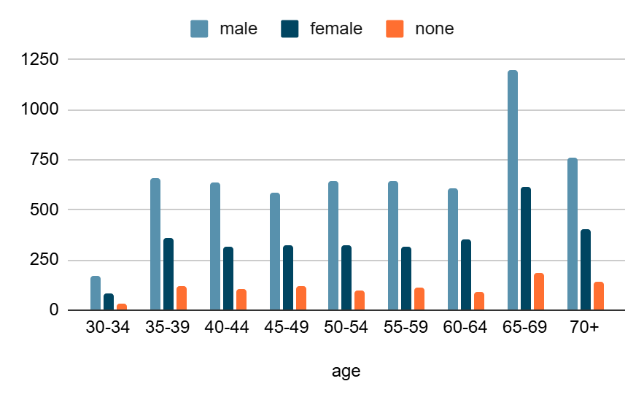
What is the regional distribution of investment customers?

Florida is a major outlier in that it’s dominated by 40–49
California shows both younger and older clusters (30–39 and 60–69).
Gender imbalance: males ≈ 59%, females ≈ 31% across the dataset — consistent male dominance in many states.
Florida, California, Northeast states are our core customer hubs.
CREATE OR REPLACE VIEW VW_REGIONAL_DIST AS SELECT CUST_STATE, COUNTRY, COUNT(DISTINCT c.CUSTOMER_ID) AS NUM_CUSTOMERS FROM CUSTOMERS c JOIN CUSTOMER_ASSETS ca ON c.CUSTOMER_ID = ca.CUSTOMER_ID GROUP BY CUST_STATE, COUNTRY ORDER BY COUNTRY, CUST_STATE;
STATE | COUNT
Alabama | 64
Alaska | 72
Arizona | 140
Arkansas | 12
California | 1037
Colorado | 254
Connecticut | 286
Delaware | 239
Florida | 1815
Georgia | 240
Hawaii | 3
Idaho | 7
Illinois | 234
Indiana | 246
Iowa | 17
Kansas | 27
Kentucky | 240
Louisiana | 35
Maine | 234
Maryland | 775
Massachusetts | 655
Michigan | 251
Minnesota | 240
Mississippi | 4
Missouri | 1
Montana | 59
Nebraska | 25
Nevada | 271
Ohio | 362
Oklahoma | 119
Oregon | 290
Pennsylvania | 417
Tennessee | 43
Texas | 353
Vermont | 1
Virginia | 401
Washington | 263
Wisconsin | 167
Wyoming | 101

CREATE OR REPLACE VIEW VW_STATE_AGE_GENDER_DIST AS
SELECT
t.CUST_STATE,
t.AGE_GROUP,
t.MALE,
t.FEMALE,
t.NONE,
(t.MALE + t.FEMALE + t.NONE) AS TOTAL
FROM (
SELECT
c.CUST_STATE,
CASE
WHEN AGE < 20 THEN '<20'
WHEN AGE BETWEEN 20 AND 29 THEN '20-29'
WHEN AGE BETWEEN 30 AND 39 THEN '30-39'
WHEN AGE BETWEEN 40 AND 49 THEN '40-49'
WHEN AGE BETWEEN 50 AND 59 THEN '50-59'
WHEN AGE BETWEEN 60 AND 69 THEN '60-69'
ELSE '70+'
END AS AGE_GROUP,
COUNT(DISTINCT CASE WHEN GENDER = 'Male' THEN c.CUSTOMER_ID END) AS MALE,
COUNT(DISTINCT CASE WHEN GENDER = 'Female' THEN c.CUSTOMER_ID END) AS FEMALE,
COUNT(DISTINCT CASE WHEN GENDER IS NULL THEN c.CUSTOMER_ID END) AS NONE
FROM CUSTOMERS c
JOIN CUSTOMER_ASSETS ca
ON c.CUSTOMER_ID = ca.CUSTOMER_ID
GROUP BY
c.CUST_STATE,
CASE
WHEN AGE < 20 THEN '<20'
WHEN AGE BETWEEN 20 AND 29 THEN '20-29'
WHEN AGE BETWEEN 30 AND 39 THEN '30-39'
WHEN AGE BETWEEN 40 AND 49 THEN '40-49'
WHEN AGE BETWEEN 50 AND 59 THEN '50-59'
WHEN AGE BETWEEN 60 AND 69 THEN '60-69'
ELSE '70+'
END
) t
ORDER BY TOTAL DESC ;

 | AGE | MALE | FEMALE | UNK | TOTAL
Florida | 40-49 | 987 | 509 | 163 | 1659
Maryland | 50-59 | 456 | 238 | 81 | 775
California | 60-69 | 329 | 177 | 46 | 552
Massachusetts | 50-59 | 306 | 150 | 49 | 505
California | 30-39 | 284 | 146 | 55 | 485
Pennsylvania | 60-69 | 241 | 123 | 53 | 417
Virginia | 70+ | 239 | 116 | 46 | 401
Ohio | 60-69 | 218 | 107 | 37 | 362
Texas | 70+ | 210 | 113 | 30 | 353
Oregon | 60-69 | 169 | 101 | 20 | 290
Connecticut | 30-39 | 164 | 91 | 31 | 286
Nevada | 60-69 | 151 | 95 | 25 | 271
Washington | 70+ | 140 | 94 | 29 | 263
Colorado | 30-39 | 148 | 85 | 21 | 254
Michigan | 60-69 | 134 | 98 | 19 | 251
Indiana | 50-59 | 153 | 68 | 25 | 246
Georgia | 40-49 | 135 | 79 | 26 | 240
Kentucky | 50-59 | 144 | 75 | 21 | 240
Minnesota | 60-69 | 146 | 71 | 23 | 240
Delaware | 30-39 | 145 | 72 | 22 | 239
Maine | 50-59 | 150 | 65 | 19 | 234
Illinois | 40-49 | 94 | 57 | 28 | 179
Wisconsin | 70+ | 105 | 43 | 19 | 167
Florida | 30-39 | 88 | 49 | 19 | 156
Massachusetts | 60-69 | 101 | 36 | 13 | 150
Arizona | 60-69 | 92 | 39 | 9 | 140
Oklahoma | 60-69 | 77 | 34 | 8 | 119
Wyoming | 70+ | 57 | 26 | 18 | 101
Alaska | 60-69 | 37 | 26 | 9 | 72
Alabama | 60-69 | 46 | 17 | 1 | 64
Montana | 60-69 | 32 | 24 | 3 | 59
Illinois | 50-59 | 28 | 23 | 4 | 55
Louisiana | 50-59 | 22 | 10 | 3 | 35
Kansas | 50-59 | 23 | 0 | 4 | 27
Nebraska | 60-69 | 11 | 10 | 4 | 25
Tennessee | 60-69 | 18 | 0 | 5 | 23
Tennessee | 70+ | 7 | 13 | 0 | 20
Iowa | 50-59 | 5 | 11 | 1 | 17
Arkansas | 60-69 | 4 | 8 | 0 | 12
Idaho | 40-49 | 7 | 0 | 0 | 7
Mississippi | 60-69 | 2 | 1 | 1 | 4
Hawaii | 40-49 | 3 | 0 | 0 | 3
Vermont | 70+ | 1 | 0 | 0 | 1
Missouri | 60-69 | 0 | 1 | 0 | 1

Florida is famously known for retirees (65+) in reality.
But our data shows Florida skewing 40–49.
The dataset is not fully representative of the real Florida population (maybe a business bias — like more mid-career professionals investing there).
Or, this investment dataset is capturing a specific customer segment (working professionals, not retirees).
California: Strong 30–39 cluster could be due to tech hubs

This data is based on working professional or investors

Are customers married, divorced, or single?

CREATE OR REPLACE VIEW VW_MARITAL_DIST AS
SELECT
MARITAL_STATUS,
COUNT(DISTINCT c.CUSTOMER_ID) AS NUM_CUSTOMERS
FROM CUSTOMERS c
JOIN CUSTOMER_ASSETS ca ON c.CUSTOMER_ID = ca.CUSTOMER_ID
GROUP BY MARITAL_STATUS;

Divorced - 1429
Single - 2312
Married - 4370
None - 1889
CREATE OR REPLACE VIEW VW_MARITAL_AGE_DIST AS
SELECT
c.MARITAL_STATUS,
CASE
WHEN c.AGE < 30 THEN '<30'
WHEN c.AGE BETWEEN 30 AND 39 THEN '30-39'
WHEN c.AGE BETWEEN 40 AND 49 THEN '40-49'
WHEN c.AGE BETWEEN 50 AND 59 THEN '50-59'
WHEN c.AGE BETWEEN 60 AND 69 THEN '60-69'
ELSE '70+'
END AS AGE_GROUP,
c.GENDER,
COUNT(DISTINCT c.CUSTOMER_ID) AS NUM_CUSTOMERS
FROM CUSTOMERS c
JOIN CUSTOMER_ASSETS ca
ON c.CUSTOMER_ID = ca.CUSTOMER_ID
GROUP BY
c.MARITAL_STATUS,
CASE
WHEN c.AGE < 30 THEN '<30'
WHEN c.AGE BETWEEN 30 AND 39 THEN '30-39'
WHEN c.AGE BETWEEN 40 AND 49 THEN '40-49'
WHEN c.AGE BETWEEN 50 AND 59 THEN '50-59'
WHEN c.AGE BETWEEN 60 AND 69 THEN '60-69'
ELSE '70+'
END,
c.GENDER;

order by NUM_CUSTOMERS

Married | 60-69 | Male | 701
Single | 60-69 | Male | 415
Divorced | 60-69 | Male | 422
Married | 60-69 | Female | 597
Single | 60-69 |  | 213
Single | 60-69 | Female | 63
 | 60-69 | Female | 308
 | 60-69 | Male | 270
Married | 30-39 | Male | 311
 | 30-39 | Female | 147
Single | 30-39 | Male | 203
 | 30-39 | Male | 119
Married | 30-39 | Female | 254
Single | 30-39 |  | 110
Divorced | 30-39 | Male | 196
Married | 30-39 |  | 38
Single | 30-39 | Female | 42
Married | 40-49 | Female | 373
Single | 40-49 | Male | 278
Divorced | 40-49 | Male | 289
 | 40-49 | Male | 192
Married | 40-49 | Male | 467
Single | 40-49 |  | 154
 | 40-49 | Female | 209
Single | 40-49 | Female | 63
Married | 40-49 |  | 63
Divorced | 50-59 | Male | 335
Married | 50-59 | Male | 498
Married | 50-59 | Female | 380
Single | 50-59 | Male | 273
 | 50-59 | Male | 181
 | 50-59 | Female | 221
Single | 50-59 |  | 153
Married | 50-59 |  | 54
Single | 50-59 | Female | 39
Married | 70+ | Female | 241
Single | 70+ | Male | 177
Married | 70+ | Male | 288
 | 70+ | Female | 135
Married | 70+ |  | 42
Divorced | 70+ | Male | 187
Single | 70+ |  | 100
Single | 70+ | Female | 29
 | 70+ | Male | 107
Married | 60-69 |  | 63

Married customers:
- Largest customer segment across all ages. (60-69, 30-39)
- They are stable, dual-income in younger groups, and asset-protection focused in older groups.
Divorced customers:
- Strong in 40–59 age groups → 824 divorced males + some females.
Single customers:
- Big in 30–49 males (career-focused, less tied down).
- Decline after 60

Is there relationship between customer’s available assets and number of dependents?

Do not include individuals who have dependents but available assets of less than $100,000

CREATE OR REPLACE VIEW VW_ASSETS_DEPENDENTS_OBJ AS
SELECT
ao.ASSET_OBJECTIVE_NAME,
c.NUM_DEPENDANTS,
COUNT(DISTINCT c.CUSTOMER_ID) AS NUM_CUSTOMERS,
round(AVG(ca.TOTAL),2) AS AVG_ASSETS,
round(MIN(ca.TOTAL),2) AS MIN_ASSETS,
round(MAX(ca.TOTAL),2) AS MAX_ASSETS,
round(SUM(ca.TOTAL),2) AS TOTAL_ASSETS
FROM CUSTOMERS c
JOIN CUSTOMER_ASSETS ca
ON c.CUSTOMER_ID = ca.CUSTOMER_ID
JOIN ASSET_OBJECTIVES ao
ON ca.ASSET_OBJECTIVE_ID = ao.ASSET_OBJECTIVE_ID
WHERE NOT (
c.NUM_DEPENDANTS > 0
AND ca.TOTAL < 100000
)
GROUP BY ao.ASSET_OBJECTIVE_NAME, c.NUM_DEPENDANTS
ORDER BY ao.ASSET_OBJECTIVE_NAME, c.NUM_DEPENDANTS;

asset obj | no if dependent | total | no of cust | avg | min | max
Family Planning | 0 | 6329179538 | 3648 | 1734972.461 | 628.42 | 5599670.92
Family Planning | 1 | 3571032127 | 1968 | 1814548.845 | 101676.47 | 5608395.37
Family Planning | 2 | 2742539811 | 1577 | 1739086.754 | 100315.99 | 5493666.11
Family Planning | 3 | 1281438886 | 822 | 1558928.085 | 102397.15 | 5149613.66
Family Planning | 4 | 2102052374 | 1161 | 1810553.293 | 102280.32 | 5615740.54
Family Planning | 5 | 919002541.4 | 616 | 1491887.243 | 106808.26 | 4335972.73
General Savings | 0 | 4277904459 | 3648 | 1172671.178 | 474.99 | 3741235.8
General Savings | 1 | 2371972677 | 1919 | 1236046.21 | 101663.92 | 3717488.74
General Savings | 2 | 1907043190 | 1553 | 1227973.722 | 100590.55 | 3742783.95
General Savings | 3 | 825207872.9 | 809 | 1020034.453 | 100486.27 | 3462727.51
General Savings | 4 | 1419804200 | 1120 | 1267682.321 | 100607.23 | 3736542.7
General Savings | 5 | 597853773.9 | 601 | 994765.0149 | 102188.94 | 2480141.04
Home Ownership | 0 | 2102323811 | 3648 | 576294.9043 | 667.57 | 1871059.51
Home Ownership | 1 | 1172287195 | 1823 | 643053.8645 | 100986.14 | 1861683.41
Home Ownership | 2 | 920678138.6 | 1442 | 638473.0503 | 100702.8 | 1869437.79
Home Ownership | 3 | 398950435.6 | 740 | 539122.2102 | 100787.42 | 1733585.44
Home Ownership | 4 | 689254266.4 | 1094 | 630031.3222 | 100629.62 | 1858587.68
Home Ownership | 5 | 303121250.6 | 578 | 524431.2294 | 100424.81 | 1355844.96
Retirement | 0 | 8520598570 | 3648 | 2335690.397 | 1069.54 | 7476418.31
Retirement | 1 | 4675795999 | 1979 | 2362706.417 | 103756.22 | 7470794.07
Retirement | 2 | 3694845104 | 1582 | 2335553.163 | 102211.43 | 7455943.87
Retirement | 3 | 1659301784 | 837 | 1982439.407 | 108275.54 | 7421654.82
Retirement | 4 | 2863814333 | 1168 | 2451895.833 | 110759.09 | 7443420.94
Retirement | 5 | 1253095546 | 626 | 2001750.073 | 104243.57 | 5668270.27
Unknown | 0 | 2164922527 | 3648 | 593454.64 | 131.04 | 1870524.68
Unknown | 1 | 1174113948 | 1828 | 642294.2823 | 100494 | 1856017.24
Unknown | 2 | 911556548.2 | 1436 | 634788.6826 | 100554.48 | 1840788.89
Unknown | 3 | 413763640.2 | 762 | 542996.9032 | 100525.74 | 1635534.01
Unknown | 4 | 730090656.8 | 1090 | 669807.942 | 101066.93 | 1849628.48
Unknown | 5 | 301436752.1 | 567 | 531634.4835 | 100953.65 | 1512469.92

Customers with 1,2 and 4 dependent have more avg assets in all categories.
Retirement is by far the largest average asset objective. There is a peak at 4 dependents.
Home Ownership much lower avg than Retirement / Family Planning. Differences by dependents are small — home ownership assets appear relatively stable across dependent counts.

What is the range of assets available across various segments? What are the average available assets? What are the customer’s maximum investable assets available in each segment?

CREATE OR REPLACE VIEW VW_ASSET_SEGMENTS AS
SELECT
c.MARITAL_STATUS,
c.GENDER,
c.NUM_DEPENDANTS,
MIN(ca.TOTAL) AS MIN_ASSETS,
MAX(ca.TOTAL) AS MAX_ASSETS,
AVG(ca.TOTAL) AS AVG_ASSETS
FROM CUSTOMERS c
JOIN CUSTOMER_ASSETS ca ON c.CUSTOMER_ID = ca.CUSTOMER_ID
GROUP BY c.MARITAL_STATUS, c.GENDER, c.NUM_DEPENDANTS
ORDER BY c.MARITAL_STATUS, c.GENDER, c.NUM_DEPENDANTS;

SCENARIO 2 - Viewing customer segments based on risk tolerance category

- What is the relationship between risk category and age?

As the age group increases, the customers are willing to take lesser risks.
For customers between 30-39, almost 31% are willing to take high risk, only 9% low risk.
For customers who are 70+, almost 25% low risk, but 19% high risk.

CREATE OR REPLACE VIEW AGE_GRP_RISK_CAT_2 AS
SELECT
CASE
WHEN c.age < 30 THEN '<30'
WHEN c.age BETWEEN 30 AND 39 THEN '30-39'
WHEN c.age BETWEEN 40 AND 49 THEN '40-49'
WHEN c.age BETWEEN 50 AND 59 THEN '50-59'
WHEN c.age BETWEEN 60 AND 69 THEN '60-69'
ELSE '70+'
END AS age_group,

COUNT(*) AS TOTAL_COUNT,

-- Counts
SUM(CASE WHEN r.risk_profile = 'LOW-RISK' THEN 1 ELSE 0 END) AS LOW_RISK_CNT,
SUM(CASE WHEN r.risk_profile = 'BELOW AVG TOLERANCE' THEN 1 ELSE 0 END) AS BELOW_AVG_TOLERANCE_CNT,
SUM(CASE WHEN r.risk_profile = 'AVERAGE TOLERANCE' THEN 1 ELSE 0 END) AS AVG_TOLERANCE_CNT,
SUM(CASE WHEN r.risk_profile = 'ABOVE AVG TOLERANCE' THEN 1 ELSE 0 END) AS ABOVE_AVG_TOLERANCE_CNT,
SUM(CASE WHEN r.risk_profile = 'HIGH RISK' THEN 1 ELSE 0 END) AS HIGH_RISK_CNT,

-- Percentages
ROUND(SUM(CASE WHEN r.risk_profile = 'LOW-RISK' THEN 1 ELSE 0 END) * 100.0 / COUNT(*), 2) AS LOW_RISK_PCT,
ROUND(SUM(CASE WHEN r.risk_profile = 'BELOW AVG TOLERANCE' THEN 1 ELSE 0 END) * 100.0 / COUNT(*), 2) AS BELOW_AVG_TOLERANCE_PCT,
ROUND(SUM(CASE WHEN r.risk_profile = 'AVERAGE TOLERANCE' THEN 1 ELSE 0 END) * 100.0 / COUNT(*), 2) AS AVG_TOLERANCE_PCT,
ROUND(SUM(CASE WHEN r.risk_profile = 'ABOVE AVG TOLERANCE' THEN 1 ELSE 0 END) * 100.0 / COUNT(*), 2) AS ABOVE_AVG_TOLERANCE_PCT,
ROUND(SUM(CASE WHEN r.risk_profile = 'HIGH RISK' THEN 1 ELSE 0 END) * 100.0 / COUNT(*), 2) AS HIGH_RISK_PCT

FROM
CUSTOMERS C
JOIN CUSTOMER_ANSWERS CA ON C.CUSTOMER_ID = CA.CUSTOMER_ID
JOIN ANSWERS A ON CA.QA_ID = A.QA_ID
JOIN RISK_PROFILE R ON A.RISK_PROFILE_ID = R.RISK_PROFILE_ID
GROUP BY
CASE
WHEN c.age < 30 THEN '<30'
WHEN c.age BETWEEN 30 AND 39 THEN '30-39'
WHEN c.age BETWEEN 40 AND 49 THEN '40-49'
WHEN c.age BETWEEN 50 AND 59 THEN '50-59'
WHEN c.age BETWEEN 60 AND 69 THEN '60-69'
ELSE '70+'
END;

select * from AGE_GRP_RISK_CAT_2;

AGE GROUP | TOTAL COUNT | LOW RISK CNT | BELOW AVG TOLERANCE CNT | AVG TOLERANCE CNT | ABOVE AVG TOLERANCE CNT | HIGH RISK CNT | LOW RISK PCT | BELOW AVG TOLERANCE PCT | AVG TOLERANCE PCT | ABOVE AVG TOLERANCE PCT | HIGH RISK PCT
30-39 | 10337 | 935 | 2030 | 1854 | 2263 | 3255 | 9.05 | 19.64 | 17.94 | 21.89 | 31.49
40-49 | 14495 | 2484 | 2442 | 2906 | 2887 | 3776 | 17.14 | 16.85 | 20.05 | 19.92 | 26.05
50-59 | 14711 | 2440 | 2517 | 3031 | 2912 | 3811 | 16.59 | 17.11 | 20.6 | 19.79 | 25.91
60-69 | 20401 | 4585 | 3015 | 4417 | 3901 | 4483 | 22.47 | 14.78 | 21.65 | 19.12 | 21.97
70+ | 8488 | 2192 | 1114 | 1931 | 1573 | 1678 | 25.82 | 13.12 | 22.75 | 18.53 | 19.77

- What is the relationship between available assets and risk category?

- Are there regional variations in the distribution of risk category?

States with more number of people who have taken part in the survey and willing to invest along with their respective risk percentages:

1. Florida
Total number of answers received: 12,652
Low risk investment environment: 16.46%
High risk investment environment: 26.61%

2. California
Total number of answers received: 7,159
Low risk investment environment: 17.33%
High risk investment environment: 24.95%

3. Maryland
Total number of answers received: 5,301
Low risk investment environment: 16.07%
High risk investment environment: 26.24%

4. Massachusetts
Total number of answers received: 4,534 Low risk investment environment: 15.90%
High risk investment environment: 25.52%

5. Connecticut
Total number of answers received: 2,097
Low risk investment environment: 8.87%
High risk investment environment: 31.24%

Risk Profile:
When we ignore the null qaid in customer ans the risk profile of a customer can be taken by mean as the risk profile are distributed we cant take mode.

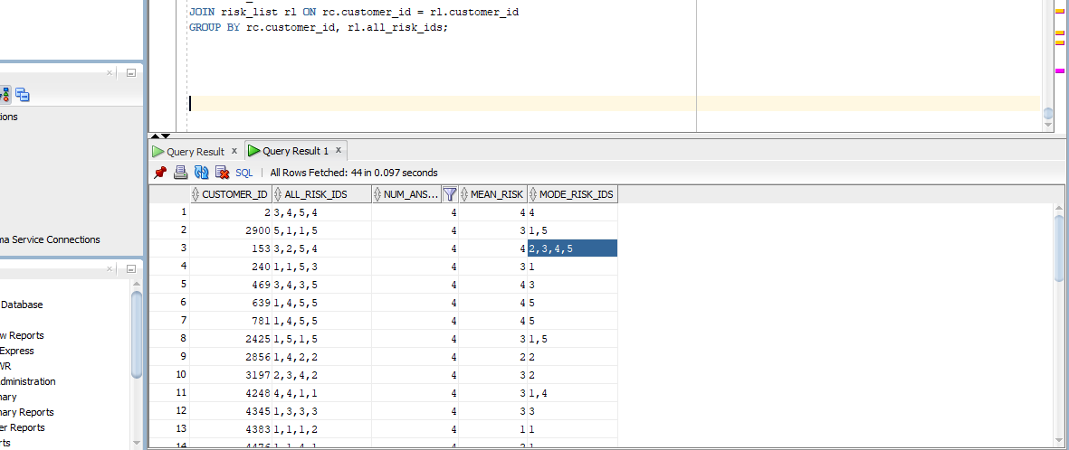

SELECT
FLOOR(c.age/5)*5 || '-' || (FLOOR(c.age/5)*5 + 4) AS age_group,
crs.num_answers,
COUNT(crs.customer_id) AS customer_count,
ROUND(AVG(crs.mean_risk), 0) AS avg_risk_profile

FROM CUSTOMER_RISK_MEAN crs
JOIN CUSTOMERS c
ON crs.customer_id = c.customer_id
GROUP BY
FLOOR(c.age/5),
crs.num_answers
ORDER BY
FLOOR(c.age/5),
crs.num_answers;

AGE | NO OF Q | NO OF CUST | AVG RISK
30-34 | 5 | 2 | 4
30-34 | 6 | 18 | 3
30-34 | 7 | 165 | 4
30-34 | 8 | 100 | 3
35-39 | 5 | 7 | 3
35-39 | 6 | 57 | 3
35-39 | 7 | 681 | 4
35-39 | 8 | 390 | 3
40-44 | 4 | 4 | 3
40-44 | 5 | 36 | 3
40-44 | 6 | 233 | 3
40-44 | 7 | 501 | 3
40-44 | 8 | 285 | 3
45-49 | 4 | 2 | 3
45-49 | 5 | 44 | 3
45-49 | 6 | 251 | 3
45-49 | 7 | 476 | 3
45-49 | 8 | 256 | 3
50-54 | 4 | 7 | 2
50-54 | 5 | 37 | 3
50-54 | 6 | 278 | 3
50-54 | 7 | 476 | 3
50-54 | 8 | 263 | 3
55-59 | 4 | 8 | 4
55-59 | 5 | 48 | 3
55-59 | 6 | 274 | 3
55-59 | 7 | 466 | 3
55-59 | 8 | 277 | 3
60-64 | 4 | 5 | 4
60-64 | 5 | 48 | 3
60-64 | 6 | 260 | 3
60-64 | 7 | 476 | 3
60-64 | 8 | 261 | 3
65-69 | 4 | 12 | 4
65-69 | 5 | 134 | 3
65-69 | 6 | 885 | 3
65-69 | 7 | 635 | 3
65-69 | 8 | 336 | 3
70-74 | 4 | 5 | 4
70-74 | 5 | 77 | 3
70-74 | 6 | 534 | 3
70-74 | 7 | 324 | 3
70-74 | 8 | 152 | 3
75-79 | 4 | 1 | 4
75-79 | 5 | 15 | 3
75-79 | 6 | 104 | 3
75-79 | 7 | 60 | 3
75-79 | 8 | 34 | 3

Most customers answered 6–8 questions across all age groups.
Very few answered only 4–5 questions (small sample sizes).
Hence, insights are most reliable in the 6–8 Q segments.

Risk profile trend across ages
- 30–34 age group:
  - At 7 Qs → very high avg risk = 4 (risk-seeking).
  - At 6 or 8 Qs → avg risk = 3 (moderate).
  - Suggests younger investors tend to be more aggressive when engaged more deeply.
- 35–44 age group:
  - Majority in risk = 3 (moderate).
  - Large customer base (e.g., 681 customers at 35–39 with 7 Qs, avg risk 4).
  - But at 40–44, risk stabilizes to 3 across all Q levels → shift to moderate investing.
- 45–64:
  - Very consistent at risk = 3, regardless of number of answers.
  - Indicates capital preservation & balanced strategies dominate this middle age range.
- 65–74:
  - Again strongly risk = 3, even with very high participation (885 customers in 65–69 answering 6 Qs).
  - But some 4 values show up when fewer questions (4 Qs), maybe aggressive subgroups.
  - Overall → senior investors are cautious/moderate.
- 75+:
  - Still moderate (risk = 3), though small subgroups with 4.
  - Participation drops sharply (smaller counts).

0 dependents → Higher risk appetite (many risk = 4).
2–4 dependents → Tend to cluster around risk = 3, showing more responsibility-driven financial choices.
5+ dependents → Small group, usually conservative, rarely above risk 3.
Young Aggressive Investors
- Age 30–39, Single/Divorced, 0–1 dependents, Risk = 4
- Best for equity-heavy, SIPs, long-term wealth creation.
Mid-career Balancers
- Age 40–49, Married, 1–3 dependents, Risk = 3
- Ideal for balanced mutual funds, insurance, retirement+children planning.
Pre-retirement Conservators
- Age 50–59, Married, 2–4 dependents, Risk = 3
- Need capital preservation, debt mutual funds, ULIPs, annuities.
Retirement Security Seekers
- Age 60–69, Married, Risk = 3
- Low-risk annuities, pension schemes, medical-linked savings.
Niche Aggressive Older Singles/Divorced
- Even in 50–69 yrs, singles/divorced show risk = 4
- Can still be pitched selective aggressive products.

Married customers → Larger numbers, mostly risk 3, conservative-moderate, with multiple dependents.
Single customers → Higher risk (often 4), fewer dependents, more aggressive investors.
Divorced customers → Mixed but many show risk 4 (higher appetite, possibly due to independent financial decision-making).

Target customer 45-65 married with 1-2 dependents

Retirement

Strongest objective in this age range.

Avg assets: ~2.5M–3.2M

Max assets: 7M+

Customer counts highest in 50–65.

Risk profile: mostly avg to above-average → willing to take moderate risk for growth.

→ Core objective for this group.

Family Planning (mainly 45–54)

Avg assets: ~1.2M–1.8M

Customers are significant until mid-50s (supporting children/education).

Drops off after 55, almost negligible at 60–65.

→ Secondary, time-bound objective.

General Savings

Steady presence across 45–65.

Avg assets: ~1.0M–1.6M

Customers prefer safety/liquidity while focusing on retirement.

→ Backup / liquidity objective.

Home Ownership

Lower avg assets (~0.7M–1.0M).

Present in 45–55, fades after 60.

→ Not primary but relevant for some (mortgage/second property).
nference (1–2 dependents only)

Priority 1: Retirement → core objective (wealth-building for retirement security).

Priority 2: Family Planning → only for 45–54 (education, dependents’ needs).

Priority 3: General Savings → liquidity buffer.

Priority 4: Home Ownership → niche, not dominant.

Target Fund:
Average risk score: ~3 (Average Tolerance).
Asset obj: retirement plan , home ownership

Asset Class | Retirement Fund % | Home Ownership Fund %
Bonds (Low Risk, 4.44% return) | 15% | 40%
Large Cap (Stable Equity, 7.85%) | 20% | 20%
US Mid Cap (Growth, 9.55%) | 15% | 5%
US Small Cap (High Volatility, 9.22%) | 10% | 3%
Foreign Ex (Volatile, 2.26%) | 5% | 2%
Emerging Markets (High Risk, 5.57%) | 10% | 5%
Commodities (Hedge, –2.62%) | 5% | 10%
Market ETF (Broad Exposure, 7.89%) | 20% | 15%

Expected return:
Retirement fund

(0.15×4.44) + (0.20×7.85) + (0.15×9.55) + (0.10×9.22) + (0.05×2.26) + (0.10×5.57) + (0.05×-2.62) + (0.20×7.89) = 6.94% (approx)
House ownership
(0.40×4.44) + (0.20×7.85) + (0.05×9.55) + (0.03×9.22) + (0.02×2.26) + (0.05×5.57) + (0.10×-2.62) + (0.15×7.89)
= 5.43% (approx)

Asset Class | Weight | Risk Level (1–5) | Contribution
Bonds | 15% | 1 | 0.15
Large Cap | 20% | 3 | 0.60
US Mid Cap | 15% | 3 | 0.45
US Small Cap | 10% | 4 | 0.40
Foreign Ex | 5% | 4 | 0.20
Emerging | 10% | 5 | 0.50
Commodities | 5% | 5 | 0.25
Market ETF | 20% | 2 | 0.40
TOTAL | 100% | — | 2.95 ≈ Risk Level 3
📈 Expected Return ≈ 6.94%
🎯 Fund Risk Level = 3 (Average Tolerance)

📊 Home Ownership Fund (Safety Tilt)
Asset Class | Weight | Risk Level (1–5) | Contribution
Bonds | 40% | 1 | 0.40
Large Cap | 20% | 3 | 0.60
US Mid Cap | 5% | 3 | 0.15
US Small Cap | 3% | 4 | 0.12
Foreign Ex | 2% | 4 | 0.08
Emerging | 5% | 5 | 0.25
Commodities | 10% | 5 | 0.50
Market ETF | 15% | 2 | 0.30
TOTAL | 100% | — | 2.40 ≈ Risk Level 2

🏦 Retirement Fund (Target Risk ~3)

1️⃣ Conservative (safer tilt, lower return)
- Bonds: 25%
- Large Cap: 20%
- Mid Cap: 15%
- Small Cap: 10%
- Emerging: 5%
- Foreign Ex: 5%
- Commodities: 5%
- ETF: 15%
➡ Return ~6.6% | Risk ~2.8

2️⃣ Balanced (optimized mix) ✅
- Bonds: 10%
- Large Cap: 25%
- Mid Cap: 20%
- Small Cap: 15%
- Emerging: 10%
- Foreign Ex: 5%
- Commodities: 5%
- ETF: 10%
➡ Return ~7.2% | Risk ~3.2

3️⃣ Aggressive (still within tolerance)
- Bonds: 5%
- Large Cap: 25%
- Mid Cap: 25%
- Small Cap: 20%
- Emerging: 10%
- Foreign Ex: 5%
- Commodities: 5%
- ETF: 5%
➡ Return ~7.7% | Risk ~3.5

🏡 Home Ownership Fund (Target Risk ~3)

1️⃣ Conservative (capital protection bias)
- Bonds: 35%
- Large Cap: 20%
- Mid Cap: 10%
- Small Cap: 5%
- Emerging: 5%
- Foreign Ex: 5%
- Commodities: 5%
- ETF: 15%
➡ Return ~5.4% | Risk ~2.7

2️⃣ Balanced (optimized mix) ✅
- Bonds: 25%
- Large Cap: 25%
- Mid Cap: 10%
- Small Cap: 8%
- Emerging: 7%
- Foreign Ex: 5%
- Commodities: 5%
- ETF: 15%
➡ Return ~6.0% | Risk ~3.0

3️⃣ Aggressive (growth tilt, but capped at ~3 risk)
- Bonds: 15%
- Large Cap: 25%
- Mid Cap: 15%
- Small Cap: 12%
- Emerging: 10%
- Foreign Ex: 5%
- Commodities: 5%
- ETF: 13%
➡ Return ~6.5% | Risk ~3.4

✅ Summary Table
Fund | Conservative | Balanced | Aggressive
Retirement | 6.6% return / 2.8 risk | 7.2% / 3.2 | 7.7% / 3.5
Home Ownership | 5.4% / 2.7 | 6.0% / 3.0 | 6.5% / 3.4

Example of a completed use case:

Use Case ID: | 1
Use Case Name: | View Interactive Campus Map
Created By: | Dan Sward | Last Updated By:
Date Created: | 4/19/09 | Date Last Updated:

Actors: | User
Description: | This use case describes the main way this interactive campus map will be used – as a web browser accessed application. The user accesses the appropriate URL and interacts with the functionality made available.
Preconditions: | Web browser opened, and interactive campus map URL accessed.
Postconditions: | User navigates from interactive campus map web site.
Normal Course: | - Open browser  - Navigate to campus map URL  - Interact with the campus map using available functionality
Alternative Courses: | None
Exceptions: | None
Includes:
Priority: | High
Frequency of Use: | Once per visit.
Business Rules | TBD…
Special Requirements: | - 24/7 access  - Response times comparable to common web mapping solutions (e.g. Google Maps)  - U of M accessibility requirements  - U of M eCommunications requirements
Assumptions:
Notes and Issues:
Use Case Graphic | 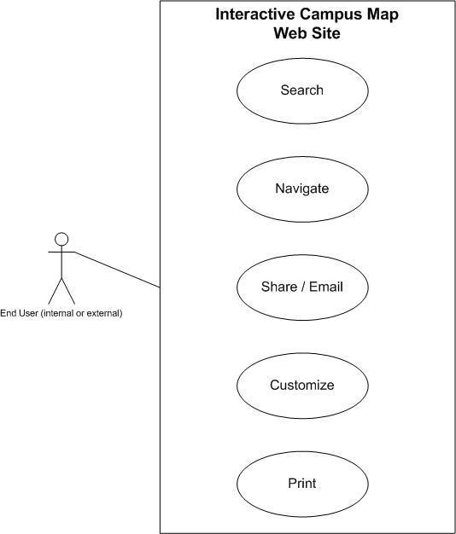

CS UCD

Financial Advisor
Use Case 1: View Segmented Customer Profile
- Description: Use Dashboard to filter and see customer data based on demographics, risk, and assets.
- Preconditions: Logged in with permissions; customer data pre-loaded.
- Postconditions: Advisor obtains insights on customer segments.
- Normal Course: Access dashboard, apply filters, analyze segments, drill down for details.
- Business Rules: Only customers meeting minimum asset and risk criteria displayed.
- Priority: High
- Frequency: Multiple times daily
Use Case 2: Recommend Suitable Fund
- Description: Use Fund Model to recommend personalized funds for customers.
- Preconditions: Customer profiles and risk scores available; system operational.
- Postconditions: Fund recommendations generated and reviewed.
- Normal Course: Input customer data, run model, get fund suggestions, advise customer.
- Priority: High
- Frequency: As needed per customer interaction
Use Case 3: Simulate Fund Performance
- Description: Use Calculator tool to simulate fund outcomes based on investment scenarios.
- Preconditions: Fund structure and parameters defined.
- Postconditions: Simulation results are reviewed.
- Normal Course: Enter parameters, run Monte Carlo or similar simulation, evaluate outputs.
- Priority: Medium
- Frequency: Per fund recommendation event
Use Case 4: Generate Fund Investment Report
- Description: Automatically generate PDF reports for fund investments and customer portfolios.
- Preconditions: Data complete and report templates ready.
- Postconditions: Reports created and available for clients.
- Normal Course: Select customer/fund, generate report, send/store PDF.
- Priority: Medium
- Frequency: Periodically or on-demand

Wealth Strategy Director
Use Case 1: View Segment Analytics
- Description: Use Dashboard to see charts and analysis of customer segments and fund performance.
- Preconditions: Dashboard available with updated data.
- Postconditions: Director gains strategic insights.
- Priority: High
- Frequency: Regularly (daily/weekly)
Use Case 2: Adjust and Approve Fund Structure
- Description: Modify fund asset allocations and approve for deployment.
- Preconditions: Proposed fund structures submitted.
- Postconditions: Fund structure approved and updated.
- Priority: High
- Frequency: As required per fund lifecycle
Use Case 3: Monitor Fund KPIs
- Description: Track fund KPIs like returns, inflows, risk using dashboards.
- Preconditions: KPI dashboards and live data feeds operational.
- Postconditions: Issues are identified and addressed timely.
- Priority: High
- Frequency: Continuously
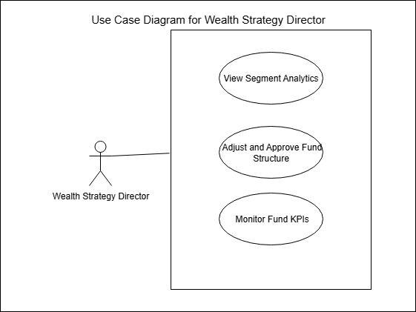

Senior Database Engineer
Use Case 1: Build Data Architecture
- Description: Design and implement database schemas and ETL pipelines.
- Preconditions: Project requirements finalized; environment configured.
- Postconditions: Data infrastructure deployed and optimized.
- Priority: High
- Frequency: Project phase based
Use Case 2: Integrate Customer Data Sources
- Description: Develop API integrations to ingest customer data.
- Preconditions: Data sources identified and accessible.
- Postconditions: Data flows automated and monitored.
- Priority: High
- Frequency: Ongoing maintenance
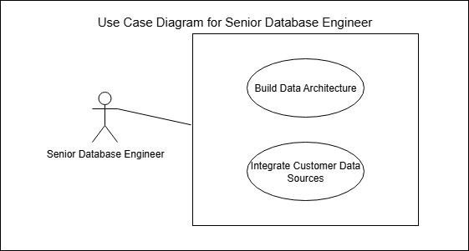

Business Analyst
Use Case 1: Document Business Requirements
- Description: Collect and formalize detailed business requirements.
- Priority: High
- Frequency: As project progresses
Use Case 2: Define Segmentation Criteria
- Description: Develop logical rules for customer segmentation.
- Priority: High
- Frequency: As needed
Use Case 3: Coordinate Dashboard Creation
- Description: Liaise between business users and developers to build dashboards.
- Priority: Medium
- Frequency: Ongoing during development

Senior Project Manager ( Reviewwww )
- Oversee project execution, coordinate teams, manage risks and delivery timelines.

Customers
Use Case 1: Register/Login
- Description: Customers create accounts and authenticate to access the investment platform.
- Preconditions: Registration page and authentication system available.
- Postconditions: Customer is logged into their personal account.
- Normal Course:
  - Navigate to platform registration/login page.
  - Enter required details (new user: registration; existing user: credentials).
  - Submit information for verification.
  - Access granted upon successful authentication.
- Alternative Courses:
  - Password recovery in case of forgotten credentials.
- Exceptions:
  - Invalid credentials entered, access denied with error message.
- Priority: High
- Frequency: Each session start or as needed

Use Case 2: Risk Assessment Survey
- Description: Customers complete a questionnaire to determine their risk tolerance profile for investment.
- Preconditions: Customer logged in. Survey tool accessible.
- Postconditions: Risk profile stored and available for recommendation engines.
- Normal Course:
  - Access risk assessment questionnaire.
  - Respond to each question honestly about investment goals and reactions.
  - Submit completed survey.
  - System calculates risk tolerance score.
  - Results stored in customer profile.
- Alternative Courses:
  - Customer may save progress and complete survey later.
- Exceptions:
  - Survey submission failure due to connectivity or system error.
- Priority: High
- Frequency: Upon account creation and periodically for update

Use Case 4: View Recommended Funds
- Description: Customers see personalized fund recommendations based on their profile and preferences.
- Preconditions: Customer completed risk assessment; recommendations generated.
- Postconditions: Customer reviews recommended investment options.
- Normal Course:
  - Access recommendation dashboard.
  - Review suggested funds with details on composition and risk.
  - Optionally, request additional info or schedule consultation.
- Alternative Courses:
  - Modify personal preferences to refine recommendations.
- Exceptions:
  - No recommendations available due to incomplete data.
- Priority: High
- Frequency: Upon interest or periodic updates

Developer
Use Case 1: Design Data Model & Architecture
- Description: Develop a robust and scalable data model and system architecture to support investment fund analytics.
- Preconditions: Business requirements defined; available technology stack.
- Postconditions: Data models and architecture documents approved and ready for development.
- Normal Course: Analyze requirements, design logical and physical data models, define architecture layers.
- Priority: High
- Frequency: Initial project phase and as needed for enhancements
Use Case 2: Implement Data Integration
- Description: Build pipelines and interfaces to integrate data from various sources into central repositories.
- Preconditions: Data sources identified; access credentials established.
- Postconditions: Data ingestion pipelines operational and monitored.
- Normal Course: Develop ETL processes, schedule jobs, validate incoming data.
- Priority: High
- Frequency: Project phase and ongoing maintenance
Use Case 3: Develop Reporting & Dashboards
- Description: Create reports and dashboards to visualize fund and customer analytics.
- Preconditions: Data models built; business requirements available.
- Postconditions: Reports and dashboards deployed and accessible.
- Normal Course: Design layouts, implement queries, create visuals, test user acceptance.
- Priority: High
- Frequency: Iterative during development
Use Case 4: Deploy & Maintain System
- Description: Deploy solution components into production environments and maintain system health.
- Preconditions: Development complete; infrastructure ready.
- Postconditions: Production system stable and updated as needed.
- Normal Course: Coordinate deployment, monitor system, patch issues, perform upgrades.
- Priority: High
- Frequency: Post-development and ongoing

(Not Rn)System Administrator
Use Case 1: Manage User Accounts & Permissions
- Description: Create and manage user identities, roles, and access permissions.
- Preconditions: Account request process established.
- Postconditions: Users have appropriate access.
- Normal Course: Process requests, configure permissions, audit access.
- Priority: High
- Frequency: Ongoing
Use Case 2: Monitor Database/Server Performance
- Description: Continuously monitor system resources and performance metrics.
- Preconditions: Monitoring tools deployed.
- Postconditions: Performance issues identified and resolved proactively.
- Normal Course: Review logs, alerts, optimize configurations.
- Priority: High
- Frequency: Continuous
Use Case 3: Backup & Recovery
- Description: Perform regular backups and manage recovery plans for data protection.
- Preconditions: Backup policies defined.
- Postconditions: Data safely backed up and recoverable.
- Normal Course: Schedule backups, test recovery, update plans.
- Priority: High
- Frequency: Scheduled

Regulatory Authority / Compliance Officer
Use Case 1: Ensure Fund Compliance with Government/SEBI Rules
- Description: Verify that investment funds adhere to applicable regulations and standards.
- Preconditions: Regulatory guidelines published.
- Postconditions: Funds certified compliant or non-compliance issues reported.
- Normal Course: Review fund structures, documentation, transaction histories.
- Priority: High
- Frequency: Periodic audits and ongoing oversight
Use Case 2: Review Audit & Compliance Reports
- Description: Analyze audit findings and compliance reports to ensure operational integrity.
- Preconditions: Audits completed; reports available.
- Postconditions: Compliance status updated; recommendations issued.
- Normal Course: Receive reports, assess risks, liaise with management.
- Priority: High
- Frequency: Scheduled

Investor Relations / Customer Support
Use Case 1: Answer Customer Queries About Funds
- Description: Respond to investor questions related to fund offerings, performance, and policies.
- Preconditions: Support systems and knowledge base in place.
- Postconditions: Customer issues resolved or escalated.
- Normal Course: Receive inquiries, research, communicate responses.
- Priority: High
- Frequency: Daily
Use Case 2: Provide Onboarding & FAQs
- Description: Guide new investors through account setup and provide access to frequently asked questions.
- Preconditions: Onboarding materials developed.
- Postconditions: Customers successfully onboarded with clear information.
- Normal Course: Conduct sessions, distribute materials, update FAQs.
- Priority: High
- Frequency: Continuous
Use Case 3: Handle Complaints
- Description: Log and resolve customer complaints timely and professionally.
- Preconditions: Complaint management system operational.
- Postconditions: Complaints addressed and documented.
- Normal Course: Record complaints, investigate, respond, escalate if needed.
- Priority: High
- Frequency: As issues arise

External Data Provider
Use Case 1: Supply Market Data
- Description: Provide continuous feeds of market indices, stock prices, and commodity rates.
- Preconditions: Data sharing agreements in place.
- Postconditions: Timely and accurate data delivered.
- Normal Course: Update data streams, ensure data integrity.
- Priority: High
- Frequency: Real-time or scheduled
Use Case 2: Feed Economic Indicators for Risk Analysis
- Description: Supply macroeconomic data (inflation, GDP, interest rates) to support risk models.
- Preconditions: Data integration configured.
- Postconditions: Economic data incorporated into analytics.
- Normal Course: Deliver datasets, update periodically.
- Priority: Medium
- Frequency: Periodic updates

Data Description : Understanding data
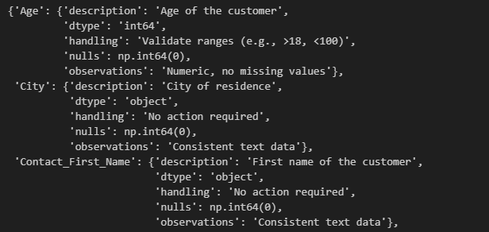
Finding number of rows and columns
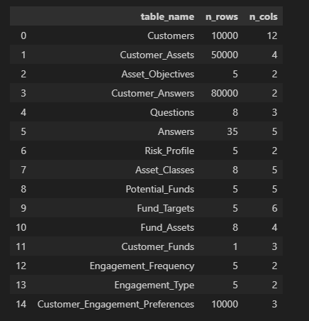

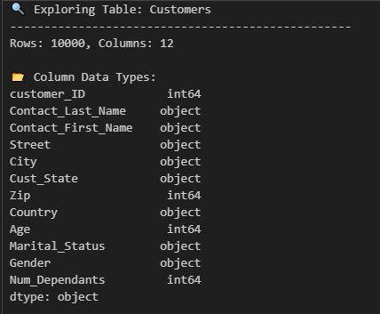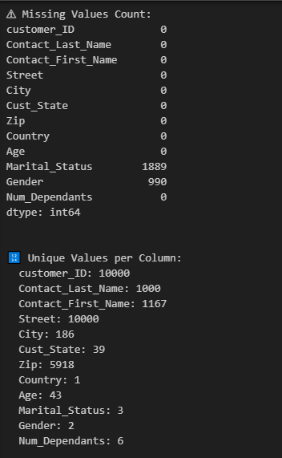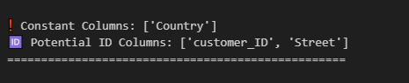
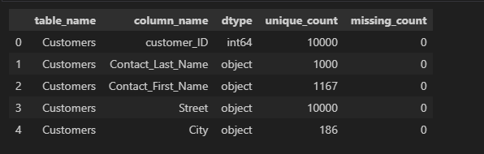
Identify Data Anomalies

Missing values → Where data is incomplete.

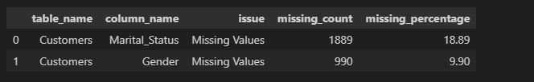
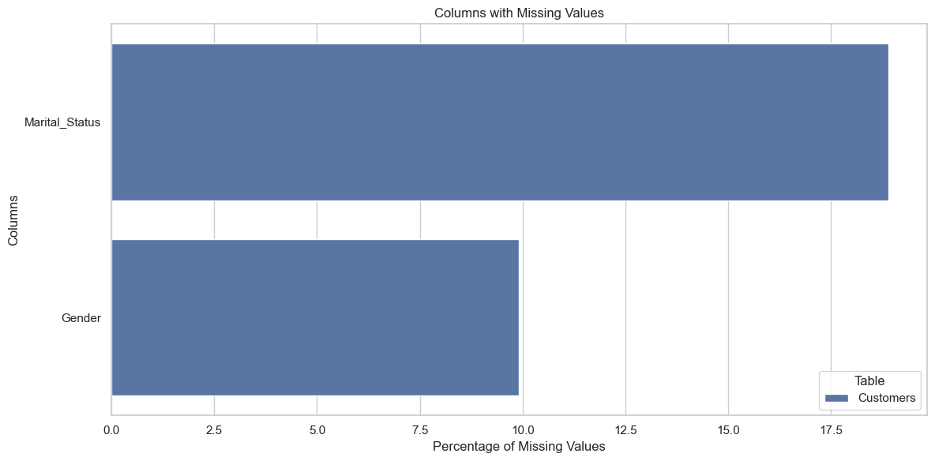

Constant columns → Where data doesn’t vary and may be useless.
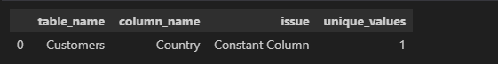

High cardinality → Where columns behave like identifiers or have too many unique values.
